Thota, Sunil Raj - LASSO Regression in R Practice.R

# Intermediate Analytics  
# ALY 6015  
# Module 3 - LASSO Regression in R Practice  
# 02/03/2021  
# Sunil Raj Thota  
# NUID: 001099670

# Get and set the working directories  
getwd()

## [1] "G:/NEU/Coursework/2021 Q1 Winter/ALY 6015 IA/Discussions & Assignments"

setwd('G:/NEU/Coursework/2021 Q1 Winter/ALY 6015 IA/Discussions & Assignments')  
getwd()

## [1] "G:/NEU/Coursework/2021 Q1 Winter/ALY 6015 IA/Discussions & Assignments"

# Installed the above packages into the work space

install.packages("datasets")  
install.packages("plyr")  
install.packages("dplyr")  
install.packages("tidyr")  
install.packages("ncvreg")  
install.packages("biglasso")  
install.packages("bigmemory")  
install.packages("glmnet")  
install.packages("lars")  
  
# Loaded the below libraries into the work space

library(plyr)

library(dplyr)

library(tidyr)

require(datasets)

library(biglasso)

library(bigmemory)

library(ncvreg)

# Exercise 1  
  
library(lars)

data(diabetes)  
attach(diabetes)  
  
View(diabetes)  
str(diabetes)

## 'data.frame': 442 obs. of 3 variables:  
## $ x : 'AsIs' num [1:442, 1:10] 0.03808 -0.00188 0.0853 -0.08906 0.00538 ...  
## ..- attr(*, "dimnames")=List of 2  
## .. ..$ : NULL  
## .. ..$ : chr [1:10] "age" "sex" "bmi" "map" ...  
## $ y : num 151 75 141 206 135 97 138 63 110 310 ...  
## $ x2: 'AsIs' num [1:442, 1:64] 0.03808 -0.00188 0.0853 -0.08906 0.00538 ...  
## ..- attr(*, ".Names")= chr [1:28288] "age" "age" "age" "age" ...  
## ..- attr(*, "dimnames")=List of 2  
## .. ..$ : chr [1:442] "1" "2" "3" "4" ...  
## .. ..$ : chr [1:64] "age" "sex" "bmi" "map" ...

head(diabetes)

## x.age x.sex x.bmi x.map x.tc x.ldl  
## 1 0.038075906 0.050680119 0.061696207 0.021872355 -0.044223498 -0.034820763  
## 2 -0.001882017 -0.044641637 -0.051474061 -0.026327835 -0.008448724 -0.019163340  
## 3 0.085298906 0.050680119 0.044451213 -0.005670611 -0.045599451 -0.034194466  
## 4 -0.089062939 -0.044641637 -0.011595015 -0.036656447 0.012190569 0.024990593  
## 5 0.005383060 -0.044641637 -0.036384692 0.021872355 0.003934852 0.015596140  
## 6 -0.092695478 -0.044641637 -0.040695940 -0.019442093 -0.068990650 -0.079287844  
## x.hdl x.tch x.ltg x.glu y x2.age  
## 1 -0.043400846 -0.002592262 0.019908421 -0.017646125 151 0.0380759064  
## 2 0.074411564 -0.039493383 -0.068329744 -0.092204050 75 -0.0018820165  
## 3 -0.032355932 -0.002592262 0.002863771 -0.025930339 141 0.0852989063  
## 4 -0.036037570 0.034308859 0.022692023 -0.009361911 206 -0.0890629394  
## 5 0.008142084 -0.002592262 -0.031991445 -0.046640874 135 0.0053830604  
## 6 0.041276824 -0.076394504 -0.041180385 -0.096346157 97 -0.0926954778  
## x2.sex x2.bmi x2.map x2.tc x2.ldl  
## 1 0.0506801187 0.0616962065 0.0218723550 -0.0442234984 -0.0348207628  
## 2 -0.0446416365 -0.0514740612 -0.0263278347 -0.0084487241 -0.0191633397  
## 3 0.0506801187 0.0444512133 -0.0056706106 -0.0455994513 -0.0341944659  
## 4 -0.0446416365 -0.0115950145 -0.0366564468 0.0121905688 0.0249905934  
## 5 -0.0446416365 -0.0363846922 0.0218723550 0.0039348516 0.0155961395  
## 6 -0.0446416365 -0.0406959405 -0.0194420933 -0.0689906499 -0.0792878444  
## x2.hdl x2.tch x2.ltg x2.glu x2.age^2  
## 1 -0.0434008457 -0.0025922620 0.0199084209 -0.0176461252 -0.0148551625  
## 2 0.0744115641 -0.0394933829 -0.0683297436 -0.0922040496 -0.0412915429  
## 3 -0.0323559322 -0.0025922620 0.0028637705 -0.0259303390 0.0916434391  
## 4 -0.0360375700 0.0343088589 0.0226920226 -0.0093619113 0.1036403301  
## 5 0.0081420836 -0.0025922620 -0.0319914449 -0.0466408736 -0.0408265979  
## 6 0.0412768238 -0.0763945038 -0.0411803852 -0.0963461565 0.1157092549  
## x2.bmi^2 x2.map^2 x2.tc^2 x2.ldl^2 x2.hdl^2  
## 1 0.0225045739 -0.0310446765 -0.0043311197 -0.0137399243 -0.0046314248  
## 2 0.0056427733 -0.0273076609 -0.0309389016 -0.0248010319 0.0400365241  
## 3 -0.0041764214 -0.0388099038 -0.0025859366 -0.0143055611 -0.0148614560  
## 4 -0.0310170859 -0.0159874156 -0.0298483890 -0.0214340114 -0.0117828858  
## 5 -0.0136807215 -0.0310446765 -0.0317282077 -0.0264236384 -0.0268506700  
## 6 -0.0088370145 -0.0327918526 0.0352626533 0.0526602897 -0.0068304035  
## x2.tch^2 x2.ltg^2 x2.glu^2 x2.age:sex x2.age:bmi  
## 1 -0.0304484629 -0.0288162192 -0.0275255618 0.0328649758 0.0405716741  
## 2 -0.0094854824 0.0371612444 0.0880219609 -0.0066099928 -0.0067648038  
## 3 -0.0304484629 -0.0348099250 -0.0224326123 0.0840517453 0.0708891293  
## 4 -0.0146503349 -0.0269850701 -0.0306820952 0.0766292449 0.0129034054  
## 5 -0.0304484629 -0.0191324512 -0.0012284185 -0.0135465959 -0.0129173209  
## 6 0.0482386067 -0.0087497144 0.0990402558 0.0800975464 0.0704832806  
## x2.age:map x2.age:tc x2.age:ldl x2.age:hdl x2.age:tch  
## 1 0.0016606410 -0.0465532511 -0.0382447104 -0.0345115069 -0.0121122609  
## 2 -0.0159342243 -0.0117287997 -0.0096555406 0.0006995477 -0.0083689963  
## 3 -0.0279128687 -0.0917442739 -0.0716415163 -0.0602920920 -0.0147605279  
## 4 0.0562904032 -0.0342989420 -0.0571356258 0.0786805432 -0.0760817036  
## 5 -0.0144024121 -0.0116206046 -0.0086502423 0.0049801694 -0.0102788452  
## 6 0.0234365273 0.1189685396 0.1438718189 -0.0851146968 0.1432199339  
## x2.age:ltg x2.age:glu x2.sex:bmi x2.sex:map x2.sex:tc  
## 1 0.0030648916 -0.0302775066 0.0621030123 0.0122820371 -0.0485722318  
## 2 -0.0102016795 -0.0113801440 0.0445181909 0.0137392710 0.0062226212  
## 3 -0.0077635174 -0.0646990887 0.0435615292 -0.0181579597 -0.0500315236  
## 4 -0.0555091413 0.0033785934 0.0067497817 0.0237941848 -0.0130586592  
## 5 -0.0165418441 -0.0208710562 0.0302274415 -0.0331836602 -0.0053461470  
## 6 0.0675437504 0.1843686827 0.0343105127 0.0070359951 0.0627810439  
## x2.sex:ldl x2.sex:hdl x2.sex:tch x2.sex:ltg x2.sex:glu  
## 1 -0.0441240238 -0.0308042981 -0.0195479919 0.0142268228 -0.0293859648  
## 2 0.0112617659 -0.0565675488 0.0224021267 0.0575880019 0.0784642525  
## 3 -0.0434530875 -0.0179545693 -0.0195479919 -0.0041216840 -0.0384231554  
## 4 -0.0304033769 0.0566194244 -0.0505546014 -0.0287218500 -0.0011399371  
## 5 -0.0215384529 0.0113446351 -0.0140762373 0.0231308241 0.0346819482  
## 6 0.0679972794 -0.0226114568 0.0588804908 0.0318440815 0.0824444620  
## x2.bmi:map x2.bmi:tc x2.bmi:ldl x2.bmi:hdl x2.bmi:tch  
## 1 0.0090008988 -0.0717180778 -0.0603176794 -0.0413575386 -0.0240342004  
## 2 0.0091148702 -0.0028355367 0.0087097314 -0.0671553344 0.0240456899  
## 3 -0.0226918084 -0.0564432291 -0.0464818380 -0.0136167525 -0.0230540270  
## 4 -0.0092925186 -0.0153834201 -0.0193921008 0.0279274131 -0.0292499537  
## 5 -0.0334523099 -0.0154230197 -0.0255070025 0.0119441348 -0.0184594644  
## 6 -0.0020460266 0.0488321410 0.0580412284 -0.0190229456 0.0476394964  
## x2.bmi:ltg x2.bmi:glu x2.map:tc x2.map:ldl x2.map:hdl  
## 1 0.0048261936 -0.0410278367 -0.0327209536 -0.0257474212 -0.0112074291  
## 2 0.0552994440 0.0806093115 -0.0070399803 0.0018462404 -0.0319794277  
## 3 -0.0194513972 -0.0423606977 -0.0062598621 -0.0049233843 0.0120934525  
## 4 -0.0280603703 -0.0160690142 -0.0214874364 -0.0291135216 0.0354925517  
## 5 0.0034088636 0.0170453175 -0.0099837004 -0.0017149265 0.0119825521  
## 6 0.0146962189 0.0634061398 0.0171122204 0.0244459437 -0.0081883427  
## x2.map:tch x2.map:ltg x2.map:glu x2.tc:ldl x2.tc:hdl  
## 1 -0.0138251131 -0.0101938361 -0.0257784633 -0.0068689647 0.0398230899  
## 2 0.0098745200 0.0203696547 0.0313619644 -0.0262353123 -0.0164622948  
## 3 -0.0122818754 -0.0203183065 -0.0149534838 -0.0065969775 0.0300168640  
## 4 -0.0397827564 -0.0385992765 -0.0109701272 -0.0242291837 -0.0122792654  
## 5 -0.0138251131 -0.0356386917 -0.0386583542 -0.0276482686 -0.0018670731  
## 6 0.0195036026 -0.0020081382 0.0201031994 0.0483666130 -0.0654803859  
## x2.tc:tch x2.tc:ltg x2.tc:glu x2.ldl:hdl x2.ldl:tch  
## 1 -0.0193030537 -0.0428915072 0.0009629700 0.0423549304 -0.0220378305  
## 2 -0.0155012002 -0.0123430995 0.0009326831 -0.0212564243 -0.0115642516  
## 3 -0.0192411418 -0.0271777643 0.0098716066 0.0335869646 -0.0220633407  
## 4 -0.0140331587 -0.0186440420 -0.0188580962 -0.0098784247 -0.0099839514  
## 5 -0.0214699727 -0.0270791696 -0.0203958711 0.0123759491 -0.0240914053  
## 6 0.0701909475 0.0350969957 0.1309600895 -0.0612519836 0.0717191451  
## x2.ldl:ltg x2.ldl:glu x2.hdl:tch x2.hdl:ltg x2.hdl:glu  
## 1 -0.0311245646 -0.0009221095 0.0334936252 0.0008521487 0.0311502576  
## 2 0.0129733755 0.0237834359 -0.0238146613 -0.0945055990 -0.1403775894  
## 3 -0.0180161691 0.0049134553 0.0329558784 0.0182807986 0.0327952439  
## 4 -0.0033727555 -0.0191092832 0.0081586184 0.0018977323 0.0215138966  
## 5 -0.0268464903 -0.0296874121 0.0309841399 0.0144891320 0.0053856590  
## 6 0.0560369456 0.1496630223 -0.0278444433 -0.0180308997 -0.0755127518  
## x2.tch:ltg x2.tch:glu x2.ltg:glu  
## 1 -0.0281911757 -0.0176581553 -0.0277936831  
## 2 0.0252977155 0.0530335390 0.1040132768  
## 3 -0.0273318271 -0.0172359590 -0.0223037368  
## 4 -0.0120454909 -0.0248722040 -0.0250419367  
## 5 -0.0255745144 -0.0161804685 0.0087351987  
## 6 0.0339989574 0.1261465729 0.0577886517

# Let's perform some Regularization analysis and techniques using "diabetes" data set. To get this data set we need to install the 'lars' package from the packages tab which is right side to the work space in R Studio.  
  
# Or we can also install the packages by using install.packages("package name") command. Once it is loaded we can use it in the code for further analysis and calculations.  
  
# Loaded the "lars" library into the work space. Loaded the diabetes Data set into the Environment. To reduce the repetitive usage of "x" in "diabetes" data set, "attach" is used to set it once throughout the work space.  
  
# To View the diabetes Data set we use View() command, To observe the structure of the Data set we use str() command, and head () and tail() shows first and last few rows in the Data set

# Exercise 2  
  
summary(x)

## age sex bmi map   
## Min. :-0.107226 Min. :-0.04464 Min. :-0.090275 Min. :-0.112400   
## 1st Qu.:-0.037299 1st Qu.:-0.04464 1st Qu.:-0.034229 1st Qu.:-0.036656   
## Median : 0.005383 Median :-0.04464 Median :-0.007284 Median :-0.005671   
## Mean : 0.000000 Mean : 0.00000 Mean : 0.000000 Mean : 0.000000   
## 3rd Qu.: 0.038076 3rd Qu.: 0.05068 3rd Qu.: 0.031248 3rd Qu.: 0.035644   
## Max. : 0.110727 Max. : 0.05068 Max. : 0.170555 Max. : 0.132044   
## tc ldl hdl   
## Min. :-0.126781 Min. :-0.115613 Min. :-0.102307   
## 1st Qu.:-0.034248 1st Qu.:-0.030358 1st Qu.:-0.035117   
## Median :-0.004321 Median :-0.003819 Median :-0.006584   
## Mean : 0.000000 Mean : 0.000000 Mean : 0.000000   
## 3rd Qu.: 0.028358 3rd Qu.: 0.029844 3rd Qu.: 0.029312   
## Max. : 0.153914 Max. : 0.198788 Max. : 0.181179   
## tch ltg glu   
## Min. :-0.076395 Min. :-0.126097 Min. :-0.137767   
## 1st Qu.:-0.039493 1st Qu.:-0.033249 1st Qu.:-0.033179   
## Median :-0.002592 Median :-0.001948 Median :-0.001078   
## Mean : 0.000000 Mean : 0.000000 Mean : 0.000000   
## 3rd Qu.: 0.034309 3rd Qu.: 0.032433 3rd Qu.: 0.027917   
## Max. : 0.185234 Max. : 0.133599 Max. : 0.135612

par(mfcol = c(2, 3))  
for (idx in 1:10)  
{  
 if (idx == 1) {  
 xLabel = "ages"  
 }  
 if (idx == 2) {  
 xLabel = "sex"  
 }  
 if (idx == 3) {  
 xLabel = "bmi"  
 }  
 if (idx == 4) {  
 xLabel = "map"  
 }  
 if (idx == 5) {  
 xlab = "tc"  
 }  
 if (idx == 6) {  
 xLabel = "ldl"  
 }  
 if (idx == 7) {  
 xLabel = "hdl"  
 }  
 if (idx == 8) {  
 xLabel = "tch"  
 }  
 if (idx == 9) {  
 xLabel = "ltg"  
 }  
 if (idx == 10) {  
 xLabel = "glu"  
 }  
 plot(x[, idx], y, xlab = xLabel)  
 abline(lm(y ~ x[, idx]), col = "tomato")  
}

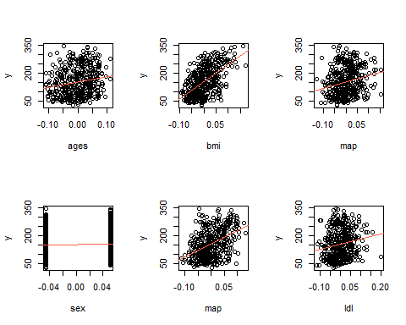

# Summary() Provides the Descriptive Stats of the x variable in diabetes Data set. Once this is done, let's find out the list of elements which are present in "x" using looping concept (for loop).  
  
# We noticed 10 variables from the statistics given in the summary. Now, let's plot Scatter plots for these variables and stack them in 2 rows and 5 columns  
  
# To generate separate Scatter Plots with the line of best fit for all the predictors in "x" as horizontal axis vs "y" as vertical axis.  
  
# In this for loop I used 'idx' as index value for "x" variable and increased the value of 'idx' by iterating the loop 10 times.  
  
# I have included conditional statements to allocate individual x-labels to their respective plots. abline() is used to plot a linear regression line on these plots.

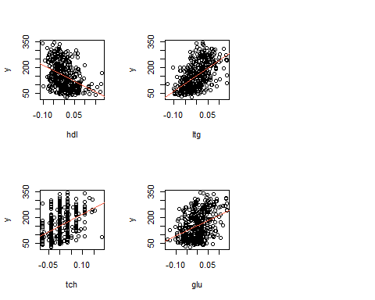

# Exercise 3  
  
linReglOLS <- lm(y ~ x)  
linReglOLS

##   
## Call:  
## lm(formula = y ~ x)  
##   
## Coefficients:  
## (Intercept) xage xsex xbmi xmap xtc   
## 152.13 -10.01 -239.82 519.84 324.39 -792.18   
## xldl xhdl xtch xltg xglu   
## 476.75 101.04 177.06 751.28 67.63

summary(linReglOLS)

##   
## Call:  
## lm(formula = y ~ x)  
##   
## Residuals:  
## Min 1Q Median 3Q Max   
## -155.829 -38.534 -0.227 37.806 151.355   
##   
## Coefficients:  
## Estimate Std. Error t value Pr(>|t|)   
## (Intercept) 152.133 2.576 59.061 < 2e-16 ***  
## xage -10.012 59.749 -0.168 0.867000   
## xsex -239.819 61.222 -3.917 0.000104 ***  
## xbmi 519.840 66.534 7.813 4.30e-14 ***  
## xmap 324.390 65.422 4.958 1.02e-06 ***  
## xtc -792.184 416.684 -1.901 0.057947 .   
## xldl 476.746 339.035 1.406 0.160389   
## xhdl 101.045 212.533 0.475 0.634721   
## xtch 177.064 161.476 1.097 0.273456   
## xltg 751.279 171.902 4.370 1.56e-05 ***  
## xglu 67.625 65.984 1.025 0.305998   
## ---  
## Signif. codes: 0 '***' 0.001 '**' 0.01 '*' 0.05 '.' 0.1 ' ' 1  
##   
## Residual standard error: 54.15 on 431 degrees of freedom  
## Multiple R-squared: 0.5177, Adjusted R-squared: 0.5066   
## F-statistic: 46.27 on 10 and 431 DF, p-value: < 2.2e-16

# In this, we need to regress "y" on the predictors in "x" using Ordinary Least Squares(OLS). The regression model was taken between "y" and "x"  
  
# Summary() gives us the descriptive stats and hypothesis testing values like Standard Error, p-Value, t-Value, r-squared value, f-Statistic, Degrees of Freedom, and etc.,  
  
# This model is used as a baseline model to collate with the next upcoming models

# Exercise 4  
  
library(glmnet)

## Warning: package 'glmnet' was built under R version 4.0.3

## Loaded glmnet 4.1

modelLASSO <- glmnet(x, y, alpha = 1)  
plot(modelLASSO,  
 xvar = "norm",  
 label = TRUE)

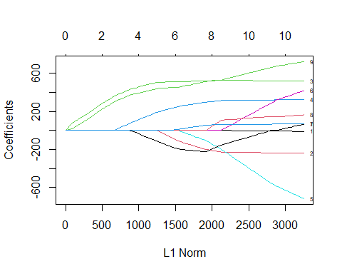

# LASSO regression is performed and for that to happen we use "glmnet" package from the packages tab to install or simply use install.packages("glmnet") command  
  
# Now, let's load the "glmnet" in our work space to regularize the model using LASSO and plot it using plot(). This plot indicates at which stage each coefficients shrinks to 0. and the lines depicts the values used by various other coefficients

# Exercise 5  
  
crossValidFit <- cv.glmnet(  
 x = x,  
 y = y,  
 alpha = 1,  
 nlambda = 1000  
)  
plot(crossValidFit)

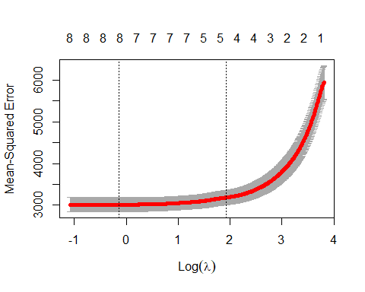

minLambda <- crossValidFit$lambda.min  
minLambda

## [1] 0.8730528

# Here, Cross Validation is used to get the best value of lambda and plot the curve using plot(). It is possible with cv.glmnet() method. nlambda signifies the number of lambda values in sequence. In general, nlambda values must be above 100.  
  
# From the plot we can depict that the value of lambda increased when the number of selected variables narrows down. This tells that higher the value of lambda, more shrink the selection is. Now, we find the min. value of lambda to get the best fit

# Exercise 6  
  
estBetaMatFit <- glmnet(  
 x = x,  
 y = y,  
 alpha = 1,  
 lambda = minLambda  
)  
estBetaMatFit$beta

## 10 x 1 sparse Matrix of class "dgCMatrix"  
## s0  
## age .   
## sex -201.065217  
## bmi 522.602018  
## map 299.095320  
## tc -111.562032  
## ldl .   
## hdl -219.228019  
## tch 8.497895  
## ltg 516.016160  
## glu 55.828353

estBetaMatFit$lambda

## [1] 0.8730528

# Here, we use the minimum lambda value again in glmnet() function to get the best fit  
  
# There are 3 coefficients namely age, ldl, tch whose values have become 0. It's clear that these variables are not so necessary to determine the value of "y".

# Exercise 7  
  
# Now we use a higher value of lambda that is within one standard error of the minimum to check its effect on shrinkage.  
  
lambdaWithOneSE <- crossValidFit$lambda.1se  
lambdaWithOneSE

## [1] 6.885531

latestFit <- glmnet(  
 x = x,  
 y = y,  
 alpha = 1,  
 lambda = lambdaWithOneSE  
)  
  
latestFit$beta

## 10 x 1 sparse Matrix of class "dgCMatrix"  
## s0  
## age .   
## sex .   
## bmi 500.1103  
## map 182.4389  
## tc .   
## ldl .   
## hdl -105.0984  
## tch .   
## ltg 434.5747  
## glu .

# Here, we use the minimum lambda value again in glmnet() function to get the best latest fit  
  
# There are 6 coefficients namely age, sx, tc, ldl, tch, and glu whose values have become 0. It's clear that these variables are not so necessary to determine the value of "y". LASSO tells that only 4 variables are necessary on which y depends. Thus the shrinkage increases

# Exercise 8  
  
linReglOLS2 <- lm(y ~ x2)  
summary(linReglOLS2)

##   
## Call:  
## lm(formula = y ~ x2)  
##   
## Residuals:  
## Min 1Q Median 3Q Max   
## -158.216 -30.809 -3.857 31.348 153.946   
##   
## Coefficients:  
## Estimate Std. Error t value Pr(>|t|)   
## (Intercept) 152.133 2.532 60.086 < 2e-16 ***  
## x2age 50.721 65.513 0.774 0.4393   
## x2sex -267.344 65.270 -4.096 5.15e-05 ***  
## x2bmi 460.721 84.601 5.446 9.32e-08 ***  
## x2map 342.933 72.447 4.734 3.13e-06 ***  
## x2tc -3599.542 60575.187 -0.059 0.9526   
## x2ldl 3028.281 53238.699 0.057 0.9547   
## x2hdl 1103.047 22636.179 0.049 0.9612   
## x2tch 74.937 275.807 0.272 0.7860   
## x2ltg 1828.210 19914.504 0.092 0.9269   
## x2glu 62.754 70.398 0.891 0.3733   
## x2age^2 67.691 69.470 0.974 0.3305   
## x2bmi^2 45.849 83.288 0.550 0.5823   
## x2map^2 -8.460 71.652 -0.118 0.9061   
## x2tc^2 6668.449 7059.159 0.945 0.3454   
## x2ldl^2 3583.174 5326.148 0.673 0.5015   
## x2hdl^2 1731.821 1590.574 1.089 0.2769   
## x2tch^2 773.374 606.967 1.274 0.2034   
## x2ltg^2 1451.581 1730.103 0.839 0.4020   
## x2glu^2 114.149 94.122 1.213 0.2260   
## x2age:sex 148.678 73.407 2.025 0.0435 *   
## x2age:bmi -18.052 79.620 -0.227 0.8208   
## x2age:map 18.534 76.303 0.243 0.8082   
## x2age:tc -158.891 617.109 -0.257 0.7970   
## x2age:ldl -67.285 494.527 -0.136 0.8918   
## x2age:hdl 209.245 280.614 0.746 0.4563   
## x2age:tch 184.960 210.330 0.879 0.3798   
## x2age:ltg 124.667 223.765 0.557 0.5778   
## x2age:glu 62.575 80.377 0.779 0.4367   
## x2sex:bmi 64.612 77.902 0.829 0.4074   
## x2sex:map 88.472 74.744 1.184 0.2373   
## x2sex:tc 433.598 590.709 0.734 0.4634   
## x2sex:ldl -352.823 468.951 -0.752 0.4523   
## x2sex:hdl -124.731 273.870 -0.455 0.6491   
## x2sex:tch -131.223 199.714 -0.657 0.5115   
## x2sex:ltg -118.995 226.493 -0.525 0.5996   
## x2sex:glu 45.758 73.650 0.621 0.5348   
## x2bmi:map 154.720 86.340 1.792 0.0739 .   
## x2bmi:tc -302.045 667.930 -0.452 0.6514   
## x2bmi:ldl 241.540 561.026 0.431 0.6671   
## x2bmi:hdl 121.942 329.884 0.370 0.7118   
## x2bmi:tch -33.445 230.836 -0.145 0.8849   
## x2bmi:ltg 114.673 255.987 0.448 0.6544   
## x2bmi:glu 23.377 91.037 0.257 0.7975   
## x2map:tc 478.303 682.264 0.701 0.4837   
## x2map:ldl -326.740 574.317 -0.569 0.5697   
## x2map:hdl -187.305 309.589 -0.605 0.5455   
## x2map:tch -58.294 198.601 -0.294 0.7693   
## x2map:ltg -154.795 271.966 -0.569 0.5696   
## x2map:glu -133.476 91.314 -1.462 0.1447   
## x2tc:ldl -9313.775 11771.220 -0.791 0.4293   
## x2tc:hdl -3932.025 3816.572 -1.030 0.3036   
## x2tc:tch -2205.910 1761.843 -1.252 0.2113   
## x2tc:ltg -3801.442 13166.091 -0.289 0.7729   
## x2tc:glu -176.295 595.459 -0.296 0.7673   
## x2ldl:hdl 2642.645 3165.926 0.835 0.4044   
## x2ldl:tch 1206.822 1470.512 0.821 0.4123   
## x2ldl:ltg 2773.697 10960.214 0.253 0.8004   
## x2ldl:glu 85.626 505.102 0.170 0.8655   
## x2hdl:tch 1188.406 1002.242 1.186 0.2365   
## x2hdl:ltg 1467.845 4609.793 0.318 0.7503   
## x2hdl:glu 217.541 296.749 0.733 0.4640   
## x2tch:ltg 389.805 624.671 0.624 0.5330   
## x2tch:glu 235.693 235.064 1.003 0.3167   
## x2ltg:glu 83.525 264.726 0.316 0.7525   
## ---  
## Signif. codes: 0 '***' 0.001 '**' 0.01 '*' 0.05 '.' 0.1 ' ' 1  
##   
## Residual standard error: 53.23 on 377 degrees of freedom  
## Multiple R-squared: 0.5924, Adjusted R-squared: 0.5233   
## F-statistic: 8.563 on 64 and 377 DF, p-value: < 2.2e-16

# In this, we need to regress "y" on the predictors in "x2" using Ordinary Least Squares(OLS). The regression model was taken between "y" and "x"2  
  
# Summary() gives us the descriptive stats and hypothesis testing values like Standard Error, p-Value, t-Value, r-squared value, f-Statistic, Degrees of Freedom, and etc., From this we can see that there are more number of predictors in x2 than x.

# Exercise 9  
  
modelLASSO2 <- glmnet(x2, y, alpha = 1)  
plot(modelLASSO2, xvar = "norm", label = TRUE)

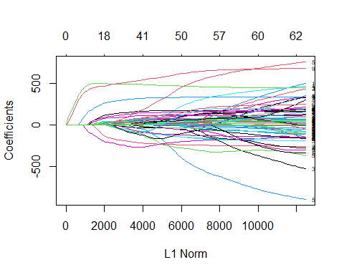

# LASSO regression is performed and for that to happen we use "glmnet" package from the packages tab to install or simply use install.packages("glmnet") command  
  
# Now, let's load the "glmnet" in our work space to regularize the model using LASSO and plot it using plot(). This plot are complex and the lines depicts the values used by various other coefficients

# Exercise 10  
  
crossValidFit2 <- cv.glmnet(  
 x = x2,  
 y = y,  
 alpha = 1,  
 nlambda = 1000  
)  
  
plot(crossValidFit2)

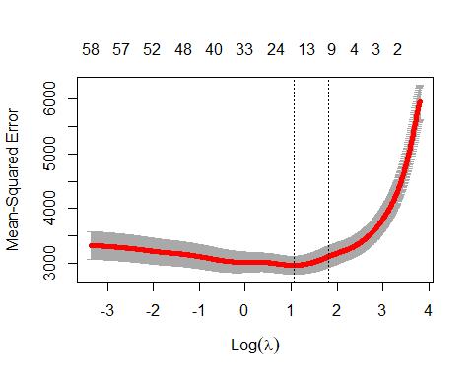

minLambda2 <- crossValidFit2$lambda.min  
  
estBetaMatFit2 <- glmnet(  
 x = x2,  
 y = y,  
 alpha = 1,  
 lambda = minLambda2  
)  
estBetaMatFit2$beta

## 64 x 1 sparse Matrix of class "dgCMatrix"  
## s0  
## age .   
## sex -116.457385  
## bmi 501.478323  
## map 254.146483  
## tc .   
## ldl .   
## hdl -190.527089  
## tch .   
## ltg 468.227778  
## glu 19.670815  
## age^2 9.718022  
## bmi^2 39.571614  
## map^2 .   
## tc^2 .   
## ldl^2 .   
## hdl^2 .   
## tch^2 .   
## ltg^2 .   
## glu^2 71.215436  
## age:sex 109.359288  
## age:bmi .   
## age:map 30.185352  
## age:tc .   
## age:ldl .   
## age:hdl .   
## age:tch .   
## age:ltg 9.451642  
## age:glu 11.123118  
## sex:bmi .   
## sex:map 1.629466  
## sex:tc .   
## sex:ldl .   
## sex:hdl .   
## sex:tch .   
## sex:ltg .   
## sex:glu .   
## bmi:map 86.745375  
## bmi:tc .   
## bmi:ldl .   
## bmi:hdl .   
## bmi:tch .   
## bmi:ltg .   
## bmi:glu .   
## map:tc .   
## map:ldl .   
## map:hdl .   
## map:tch .   
## map:ltg .   
## map:glu .   
## tc:ldl .   
## tc:hdl .   
## tc:tch .   
## tc:ltg .   
## tc:glu .   
## ldl:hdl .   
## ldl:tch .   
## ldl:ltg .   
## ldl:glu .   
## hdl:tch .   
## hdl:ltg .   
## hdl:glu .   
## tch:ltg .   
## tch:glu .   
## ltg:glu .

estBetaMatFit2$lambda

## [1] 2.921225

# Here, Cross Validation is used to get the best value of lambda and plot the curve using plot(). It is possible with cv.glmnet() method. nlambda signifies the number of lambda values in sequence. In general, n lambda values must be above 100.  
  
# From the plot we can depict that the value of lambda increased when the number of selected variables narrows down. This tells that higher the value of lambda, more shrink the selection is. Now, we find the min. value of lambda to get the best fit  
  
# Here, we use the minimum lambda value again in glmnet() function to get the best fit. There are 50 coefficients whose values have become 0. It's clear that these variables are not so necessary to determine the value of "y". With this it shrinkage's the variables and it regularizes the model.